**New user Process:**

1. Navigate to [www.okta.com](http://www.okta.com)
2. Sign in.
3. Under “Users”, select “People”:

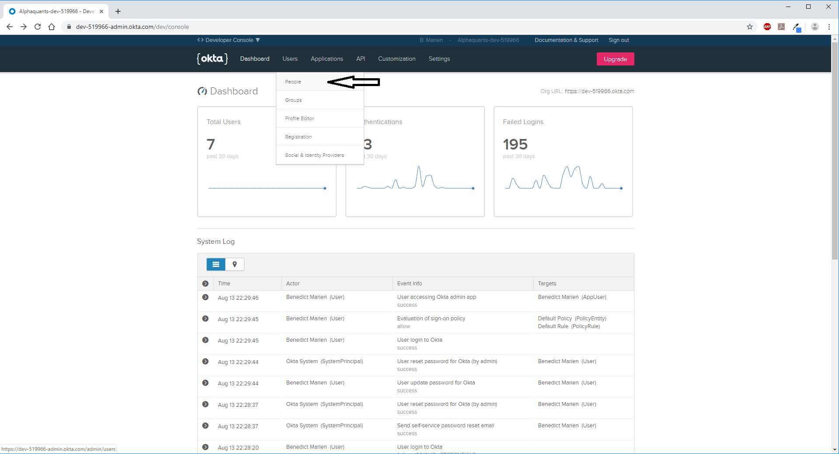

1. Select the “Add Person” option.
2. Fill in relevant information. The most important input is the email box since this is not going to be modifiable in the near future. Password should be set to “Set by user” and “Send user activation email now” box deselected. Click “Save”.

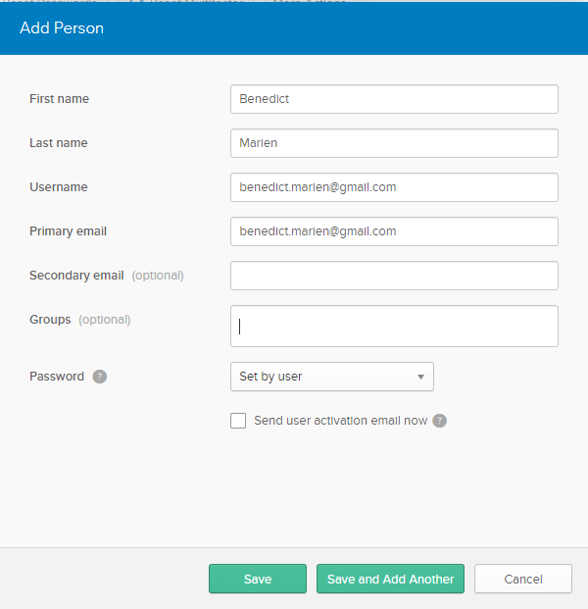

1. Navigate to <https://cloud.mongodb.com/user>
2. Login using credentials.
3. Click on “Collections”.
4. Click on “Insert document”.
5. Insert relevant KEY/VALUE pairs. (username, email, phone, company, address, balance, equity, performanceIncrease, performanceInception, performanceMonth, performanceDay). The “_id”, “createdAt” and “updatedAt” keys and values are created automatically.
6. NOTE: The email must be identical to the user’s Okta email otherwise the data will not appear on the dashboard.
7. Click “Insert”.